Getting home appraised becoming more important than broker's first offer
BY JASON SHEFTELL
DAILY NEWS REAL ESTATE CORRESPONDENT
Friday, December 21st 2007, 4:00 AM
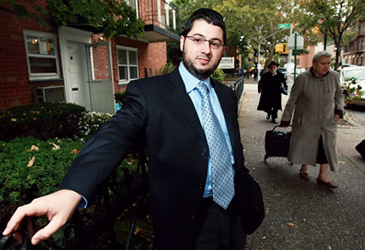
.
Appraiser Sam Heskel, on the streets of Borough Park. Warga/News

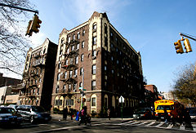
One floor above a cemetery headstone shop on a retail stretch across from the Beth Jacob girls' school on 14th Ave.
in Borough Park, Sam Heskel, 31, runs a nine-year-old appraisal business. It's as unassuming a place of work for a real estate expert as Trump Tower is assuming.
"An appraisal is simply an exact opinion of the market value of your home," says Heskel, who has lived in Borough Park his entire life and does appraisals in Brooklyn, Queens, Manhattan, New Jersey and Long Island. "A broker will tell everything looks beautiful in a home. With appraisals, we try to get closer to the truth."
A prewar apartment building on 14th Ave. Hagen for News
Busy because of the mortgage crunch that has banks appraising the value of homes up for foreclosure, Heskel's HMS Associates tells the banks exactly what he thinks your house is worth. Most mortgage banks and lending institutions always have a house appraised by a New York state licensed appraiser before loan approval.
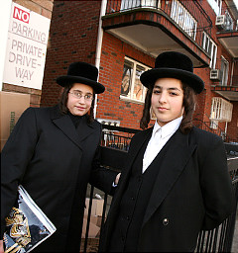
The price of an average appraisal on a three-bedroom house costs between $350 and $500. Most consumers just allow brokers to tell them the value of their home. At that price, it's surprising that homeowners don't have their homes evaluated more.
"Most homeowners don't bother to have their homes appraised because they aren't aware of how little it costs," says Heskel. "The first-time homebuyer has no idea how the process works."
Working in Borough Park and other tri-state area real estate markets keeps Heskel aware of the importance of location and home upkeep when determining the value of a home.
"An appraiser looks at water, the electricity, the boiler, the ceilings and the general conditions of the house," says Heskel. "If we see a stain or smell water in the basement, we know there might be trouble. If the Sheetrock is warped from water, we lower the value."
Teenage boys after a day in school. Hagen for News
Heskel is quick to point out he is not an engineer or a home inspector, but he is a licensed state-trained appraiser with 120 hours' coursework and sufficient experience as an apprentice in the field.
"I can't tell you how solid the beams are in your house or the exact type of wood used on your floorboards or home exterior," he says. "But engineers or inspectors don't have the market knowledge to understand all the dynamics impacting home value."
Heskel studies market shifts, especially in local neighborhoods. His real estate knowledge is as strong as any expert's I've encountered.
In this Brooklyn area, he has watched home prices rise dramatically as the neighborhood increased in popularity.
"It's supply and demand in Borough Park," says Heskel, who doesn't waste words. "It's the most sought-after neighborhood for an Orthodox Jew in the region. The schools, the shopping, the families, the synagogues, they're all here."
Last Friday afternoon, Borough Park was as energetic and colorful as any New York neighborhood. Preparing for Sabbath, the Friday night holiday observed with no electricity, a family dinner and quiet prayer, the Orthodox residents of Borough Park rushed around buying flowers for the dinner tables, challah bread for blessings, cakes, cookies and candles.
Bakeries, food shops, home decor shops, hosiery stores, wigmakers, and Sherles, a specialty shop selling high-end women's hats, dominate the retail stretch on 13th Ave. between 44th and 52nd Sts. Just 25 minutes from downtown Manhattan, Borough Park enjoys Old Country family values in an urban setting.
Dozens of yellow school buses block the streets in front of the Jewish yeshivas (schools for religious and secular education). Frustrated drivers honk their horns furiously, attempting to avoid the bottleneck of buses that close some streets for more than an hour. Young male children dressed in black coats and hats similar to their adult fathers and little girls dressed in multi-colored scarves and hats laugh and scream like it's the last day of school.
Averaging slightly less than four children per family, Borough Park families have unique living needs. To meet the growing demand for housing in the crowded neighborhood, developers are tearing down 100-year-old decaying single-family homes built by Irish and Italian immigrants to construct three-family brick condominiums.
"There is no better neighborhood to be in if you have kids and are Orthodox," says Heskel. "It's so good, in fact, that prices have gone way up, forcing some young married couples to leave."
Ten years ago, prices for single-family homes cost $400,000 to $500,000. Three to four years ago, they were $800,000. Now those homes can sell for $1.3 million.
Two-bedroom condos sell for $535,000. Rents also have seen increases. A two-bedroom apartment rented for $1,200 three years ago. Now, it's closer to $1,700. One-bedrooms can go for as much as $1,200 now.
"These are still good prices, compared to other Brooklyn neighborhoods," says Heskel. "Just look at Park Slope or Prospect Heights."
Due to its close-knit community, homeowners often sell their homes through word of mouth. In fact, Borough Park is the first neighborhood where I did not see a "For Sale" sign. Even when homes are sold by non-Orthodox residents, the deals are often negotiated earlier.
"When a non-Orthodox person moves out of the neighborhood, chances are, several Orthodox families have already requested to bid on the house," says Heskel. "Sometimes, the seller even prices it higher because they think an Orthodox family will pay more to live there. In some cases, they do; driving the prices up even more."
All of these factors help Heskel determine the fair price of a home all over the five boroughs and New York area.
"I love analyzing the market and feeling the energy on the streets as a neighborhood shifts in demographics and value," he says. "Places like Kensington in Brooklyn and Sunnyside and Woodside in Queens are all seeing an increase in value.
"Just smell the new developments to see what areas are doing well," Heskel says

