FASHION
DECEMBER 20, 2008

APPARAL

Fashion's Closet Raiders

Recession forces new strategies for the clothing-conscious

By TERI AGINS
Anne Marie Harrison knows that purple is the hottest shade in fashion this season. But rather than hit the malls she's rearranged her closet, moving all of the purple sweaters, dresses and shoes she already has to the front, to make her wardrobe look more up-to-date.
Now that even the most rabid fashionistas have stopped spending, some stylish consumers are going for recession chic -- figuring out how to turn their existing garb into trendy ensembles. Some people are even hiring outside consultants to assist them.
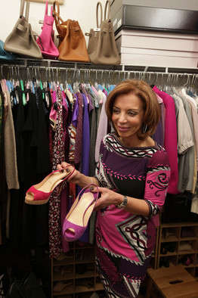
Thirty-six-year-old New Yorker Babette Shennan recently spent $405 for a three-hour consultation with Julie Biondi, an independent stylist who works with the Abigail Michaels Concierge Co., which mans desks in upscale residential buildings in Manhattan. Abbie Newman, a principal at Abigail Michaels, says the company has seen a spike in requests for closet makeovers in recent months, surpassing what used to be a more common request -- for personal shoppers.
Ms. Biondi helped Ms. Shennan pull together 10 outfits from pieces she already owns, including combinations such as her four-year-old gray pencil skirt paired with a green satin cocktail shell and a turquoise-green cardigan. Ms. Biondi also sent Ms. Shennan to a tailor who charged around $100 to alter three forgotten items -- a shapeless sequin top and two pair of pants in need of tapering.
In addition, Ms. Biondi taught her a fashion-show trick: how to layer a thin long top, in this case, a pink one, under a shorter white knit top, so that a sliver of pink peeked out at the bottom. "Just like the way they show it in the fashion magazines," Ms. Shennan says.
Today's economy has forced many clothes horses "to take stock of their closets and to see what they really have," says stylist Lloyd Boston, who does in-store fashion makeovers with customers in conjunction with his consulting work for the Jones New York brand.
Others are mining their closets for items they can sell to fund new purchases. Mercedes Leon, a vice president at a nonprofit in New York, sold broken gold jewelry and single earrings for $2,000 earlier this year. She's bought a few new, modestly priced pieces of clothing such as cashmere sweaters in purple and orange for $60 each at the discounter Syms that "will look good with a black skirt," she says.
Jon Roemer for The Wall Street Journal
Anne Marie Harrison with Chirstian Louboutin shoews she bought on eBay.
As for Ms. Harrison, the recession, coupled with her desire to save money for a down payment on a condo, has largely kept her out of the malls in recent months. When she does go shopping, she looks for pieces that won't telegraph their purchase dates by avoiding extreme runway looks and obviously trendy pieces. The Lyndhurst, N.J. brand manager has a large collection of classic sheath dresses from department store brands such as David Meister, Nicole Miller, Diane von Furstenberg and Anne Klein. She scouts for the most interesting fabrics and detailing -- pop-art prints, shiny lamé embellishments, rouching and asymmetrical necklines.
"I don't buy anything that is identifiable by the name designers or logos," Ms. Harrison says, "so that you can't tell how old my clothes are."
Write to Teri Agins at teri.agins@wsj.com

