Real Estate
Big Deal
How to Dress a Lobby
By JOSH BARBANEL
Published: September 30, 2007
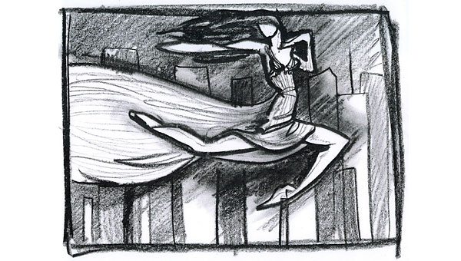
VERA WANG, the designer first known for her couture wedding dresses, someday hopes to have her own branded hotel or resort. In the meantime, she is leaving her mark on a new condominium project on Eighth Avenue and 28th Street in Chelsea.
Ms. Wang is in the midst of creating a large work in plaster for the lobby of the Onyx Chelsea, featuring a woman, perhaps a Greek goddess, in a flowing tulle silk gown, fluttering high over an angular New York skyline.
The design for the relief sculpture was released only last week, long after the promotional materials for the glass, granite and metal condominium were designed, and after about 50 of the 52 apartments were said to be in contract.
Ms. Wang said the notion of doing a work for the lobby was first raised a few years ago by a friend, Matthew Bronfman, a developer and heir to the Bronfman liquor fortune, who is building the Onyx Chelsea along with a partner, Evan Haymes. At first, it was to be a tapestry, but over the last few months it evolved into something else.
The idea was to link the angular modern building to the surrounding community, which is dominated by the Fashion Institute of Technology, down the street. “The fluid figure leaping over the tall buildings signifies grace and fluidity against the harshness and angles of the New York skyline,” Ms. Wang said. “A floating presence over the city.”
She said that the gown was based on one in the permanent collection of the Victoria and Albert Museum in London, and that the delicate silk would be preserved in plaster for posterity. The entire work will be finished in a white or ivory plaster. “I’m not daring to call it art,” she said.
The building, which includes a dozen apartments with terraces, is due to open in mid-October, Mr. Haymes said, adding that the two available units are a two-bedroom and a three-bedroom penthouse with an 889-square-foot terrace.

Copyright 2007 The New York Times Company

