July 8, 2009
NEW YORK | The Business of New York Real Estate: Timely Information, Trusted Analysis and Valuable Resources Online | SIGN UP FOR OUR NY ALERT

EXCLUSIVE Last updated: July 8, 2009 01:17pm
Carlton To Raise $150M for Apt. JV

NEW YORK CITY-Carlton Advisory Services has been retained to raise approximately $150 million of joint venture equity on behalf of multifamily owner/operator the Dermot Co. The JV’s business plan is to acquire rental apartment properties in the New York City metro area and other Northeastern markets.
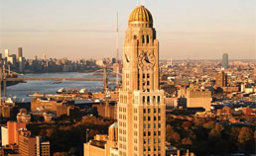
One Hanson Place
According to a release, the JV will target an overall IRR of approximately 20% via the acquisition and strategic disposition of well-located, middle class multifamily properties. The plan is to pursue properties in commuter-friendly neighborhoods with repositioning potential, target opportunities in broken-condominium properties and purchase select below-par, performing or non-performing whole loans. Handling the transaction for CAS will be the Carlton Group’s Michael Campbell, Steven Fenster, John Bralower and Tom Graziano.
Currently, the Dermot Co. has more than $1.1 billion of assets under management. Among its multifamily properties is One Hanson Place, also known as the Williamsburgh Savings Bank Building, still the tallest building in Brooklyn and among the tallest four-sided clock towers in the world.

